# HOW TO PRACTICE THE RECORDER

**RECORDER PRACTICE STEPS~Don’t make noise, Make MUSIC!**

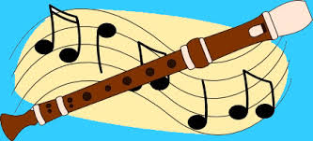

**JUST DO IT!**

* 1. Point & Say
* 2. Finger & Say
* 3. Play the Song!!!
* **Hint: Make sure you are completely comfortable with each step before you go to the next step.**

# HOW TO PRACTICE THE RECORDER

**RECORDER PRACTICE STEPS~Don’t make noise, Make MUSIC!**



**JUST DO IT!**

* 1. Point & Say
* 2. Finger & Say
* 3. Play the Song!!!
* **Hint: Make sure you are completely comfortable with each step before you go to the next step.**

# HOW TO PRACTICE THE RECORDER

**RECORDER PRACTICE STEPS~Don’t make noise, Make MUSIC!**



**JUST DO IT!**

* 1. Point & Say
* 2. Finger & Say
* 3. Play the Song!!!
* **Hint: Make sure you are completely comfortable with each step before you go to the next step.**